2B Displaying Single Data Sets – Lesson 11
Statistics – Misleading Graphs.

Name: _________________

- Explain the three types of misleading graphs we have considered.

- Displaced axis

- Exaggerated use of area or volume

- Irregular Scale

- Why do you think people create misleading graphs?

- How are the following graphs misleading? [See Question 1]

  - One company is doing very badly? b) Business has doubled.

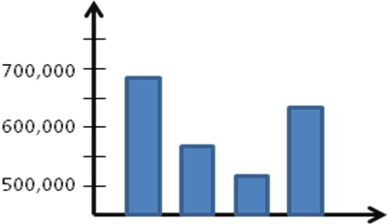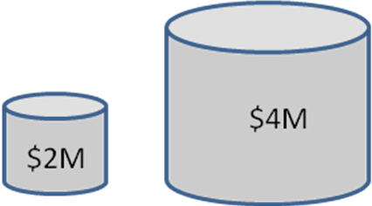

c) d)
5,000
10,000
20,000
10,000
15,000
20,000
5,000

______________________ _______________________

e) f)

100
200
300
0
June
Sep
Dec
$290,000
$300,000
$310,000
2008
2010
Average House
Prices

______________________ _______________________

- h) Source: www.yale.edu/ynhti/curriculum
/units/2008/6/08.06.06.x.html
1
2
4
8
16
0
1
2
3
4
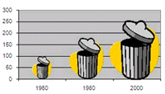

______________________ _______________________

- Go to Google Images and find an example of misleading graphs. Write the URL below.

http:// _______________________
